FPS Performance, Model, and Counting Logic – Clarifications
This document answers the questions raised regarding FPS performance, asynchronous processing, model choice, lag, datasets, and counting logic. All answers are based on experiments performed so far on Raspberry Pi using YOLOv8n (head detection only).

2. FPS vs Performance Graph & Asynchronous Processing

FPS vs Frame Number Graphs
We have generated FPS vs Frame Number graphs for two scenarios:
- Synchronous (normal real-time processing)
  - FPS fluctuates significantly.
  - Initial frames show lower FPS due to model warm-up.
  - Occasional FPS drops occur when detection + tracking + display happen in the same loop.
- Asynchronous / Multi-threaded processing
  - FPS is more stable.
  - Average FPS is around 11–12 FPS.
  - Frame drops are minimal compared to synchronous execution.

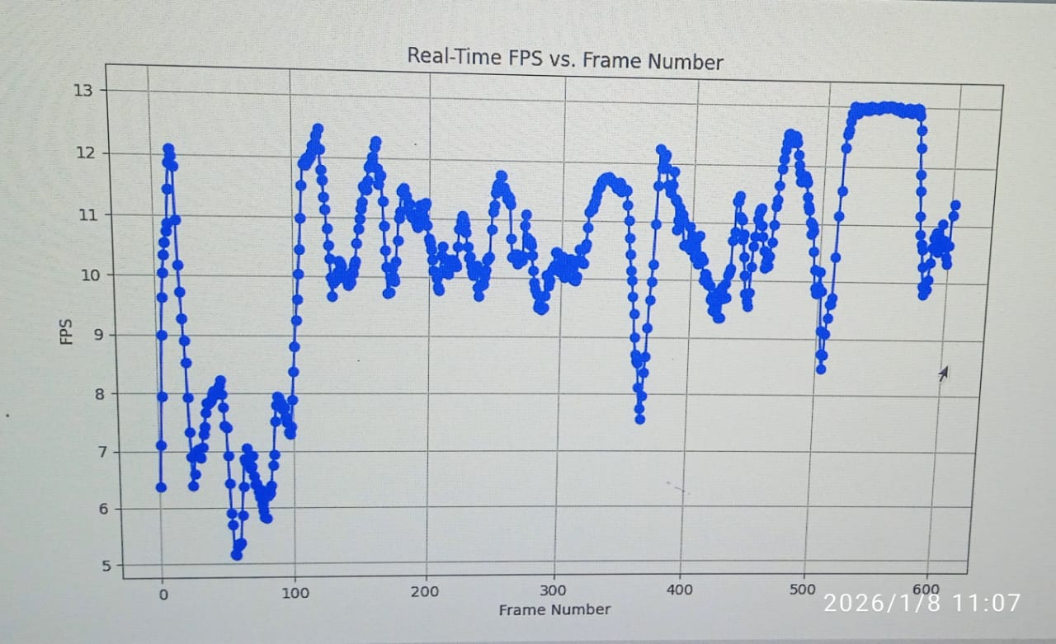

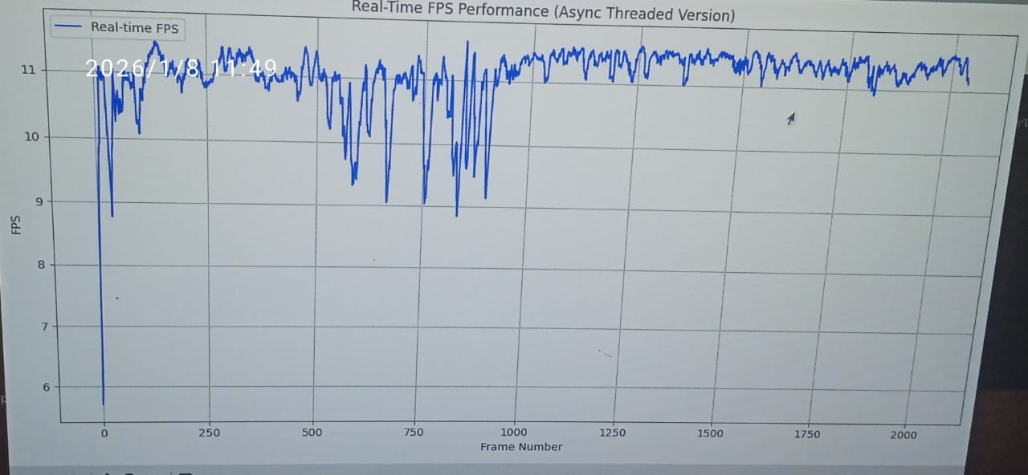

Conclusion:
Asynchronous processing clearly improves stability and real-time performance by decoupling frame capture, inference, and display.

Tracker Used
- Currently using YOLOv8 built-in tracking (ByteTrack-style default).
- No external tracker (like DeepSORT) is added yet to keep computation light for Raspberry Pi.

Model Clarification
- YOLOv8n is used only for head detection
- It is not full body / person detection in this project.
- The model is trained specifically on overhead and head-focused datasets.

3. Lag Issues with Multiple Feeds

Current Status
- Multiple camera feeds are NOT tested yet.
- With a single feed, there is no major lag issue.
- Current real-time performance: ~12 FPS on Raspberry Pi.

Metrics (Current – Single Feed Only)
Parameter | Value
Device | Raspberry Pi
Model | YOLOv8n (Head detection)
Input Resolution | 640 (training) / 320 (inference – TFLite)
FPS | ~11–12 FPS
No. of Feeds | 1
Metrics for Image Resolution vs FPS vs Performance vs No. of Feeds will be generated once multi-camera testing is done.

3a. Jetson vs Raspberry Pi
- NVIDIA Jetson testing is not done.
- Reason: High cost and project scope limitations.
- As suggested by Narayana Sir, deployment focus is only on Raspberry Pi.
- Jetson is expected to give higher FPS, but it is outside current requirements.

4. Dataset & Training Details

Dataset Source
- Primary dataset example (Roboflow):
https://app.roboflow.com/agrisense-puixp/overhead-eeifj-e45ta/2
- Multiple head detection datasets from Roboflow were mixed.
- Total dataset size: ~21,000 images.

Dataset Format
- Converted to COCO format.
- Training performed on Kaggle.

Training Configuration
Parameter | Value
Model | YOLOv8n
Task | Head detection
Training Image Size | 640
Dataset Size | ~21k images

Inference Optimization
- Model optimized to TensorFlow Lite (TFLite).
- Only supports 320 image size after optimization.
- Inference tested at 320 resolution only.

Resolution Impact
- Reducing resolution from 640 → 320:
  - ✔ Improved FPS
  - ✔ Acceptable detection accuracy
- Further reduction below 320 is not tested yet.

Counting Logic – Peeping Head & Duplicate Count Issue

Observed Issue
- If a person peeps head out and pulls back, the IN and OUT count increases repeatedly.
- This confirms the limitation pointed out by Madan Sir.

Current Understanding
- Track ID remains same (Track = 1), but:
  - Entry and exit line crossing logic triggers multiple count.
- The real requirement is:
  - To know how many passengers are currently inside the bus.

Net Count Logic (Current Approach)
- Maintain:
  - IN_count
  - OUT_count
- Calculate:
  - Net passengers = IN − OUT
Even if a person peeps and causes simultaneous IN and OUT counts: - Net passenger count remains correct.
✔ This logic is sufficient for bus passenger occupancy estimation, which is the primary use case.

Summary
- Asynchronous processing improves FPS stability (~12 FPS).
- YOLOv8n is used only for head detection.
- Single-camera setup tested; no lag issues currently.
- Raspberry Pi is the target deployment device.
- Dataset is mixed Roboflow head datasets (~21k images, COCO format).
- Net counting logic is sufficient for bus passenger estimation.
- Real-world data collected for testing

